Project BR04D$W0RD Data Diagrams

**ERD**

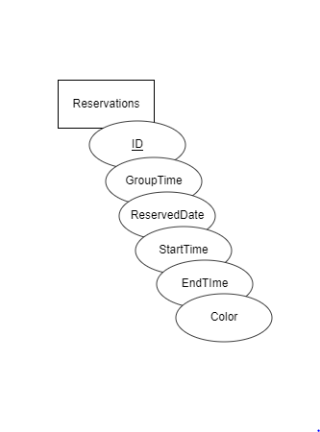

Table Name: Reservations

* ID INT AUTOINCREMENT
* GroupTime VARCHAR (100)
* ReservedDate DATE
* StartTime TIME
* EndTime TIME
* Color VARCHAR (10)

**Data Flow Diagram**

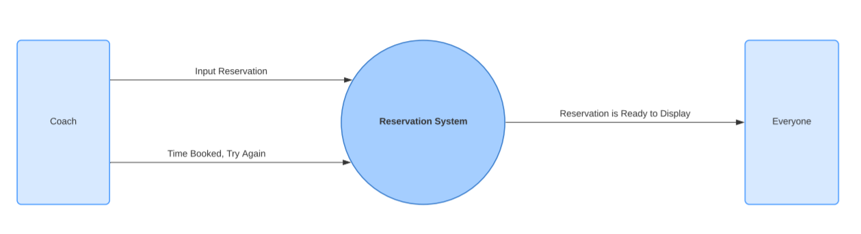

**Sequence Diagram**

